Model-View-Controller (MVC) Model

1.Insert new reserve the rooms

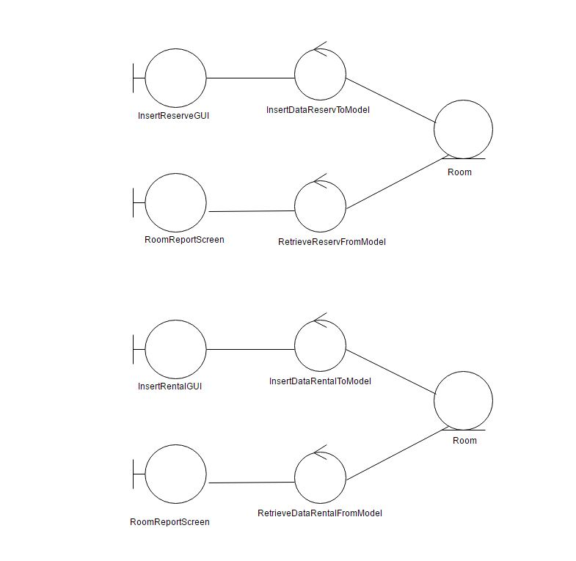

2. Insert new rental the rooms



3.Delete reserve the rooms

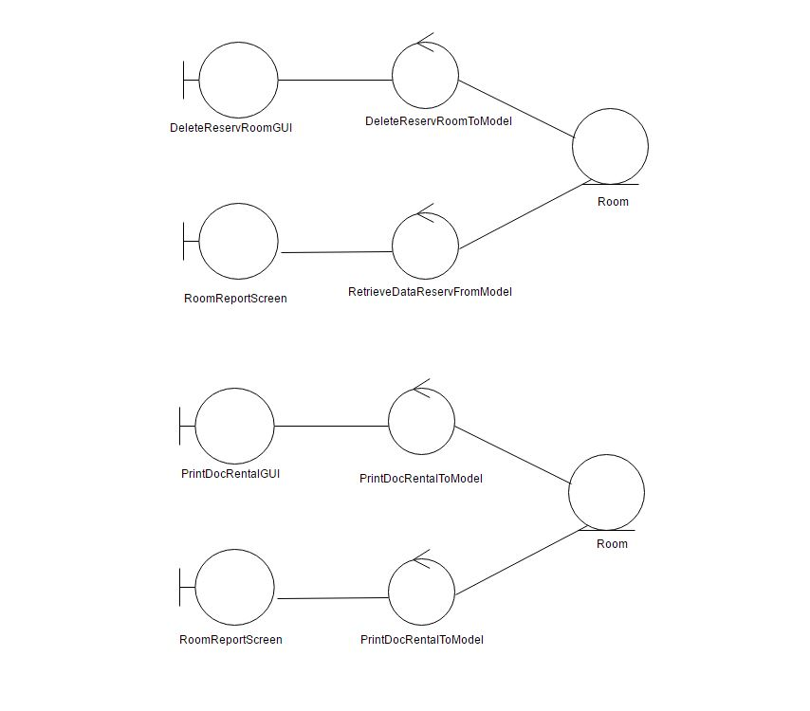

4 Print document rental agreement

